[**Jim**](http://ohiobasketballhalloffame.com/?p=2175) **Morgan to be inducted into the Ohio Basketball Hall of Fame on May 18, 2013**

[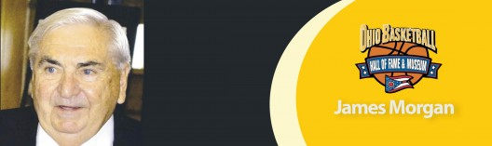](http://ohiobasketballhalloffame.com/wp-content/uploads/James-Morgan-e1346863130636.jpg)

**Birthdate:** June 13, 1934  
**Birthplace:** Leslie County, Kentucky  
**High School:** Dayton Stivers (1953)  
**College:** University of Louisville (1957)

Jim Morgan enjoyed both personal and team success at Dayton Stivers High School and the University of Louisville. A scrappy guard, Morgan sparked Stivers teams that won City League championships in 1951 and 1953 and a district title in 1952. The 1953 team, which also featured 2011 Hall of Fame inductee Gene Millard, was ranked No. 1 in the state but lost in the district final. Morgan played on some very good Louisville teams, including the 1956 National Invitation Tournament champions. He averaged 7.9 points as a sophomore, 14.4 as a junior and 17.4 as a senior when he was team captain. Louisville had records of 18-9, 26-3 and 21-5 in those three seasons. Asked to select a starting five of those who played for the Cardinals during Coach Peck Hickman’s 23 years (1944-1967) as head coach, five prominent members of the Louisville media included Morgan in that quintet along with Wes Unseld, John Turner, Charlie Tyra and Phil Rollins. Morgan spent eight years as boys basketball coach at Dayton Stebbins High School before embarking on a successful career as a thoroughbred horse trainer.